Time and Attendance
PC Manual

Lawson SEA
SELF-EVIDENT APPLICATIONS
Time and Attendance

Handbook Version 1 – Time and Attendance
SEA vs. 1.0

SEA
https://employeeinfo.dpsk12.org

Training Documentation
http://hr.dpsk12.org/sea/training

Certification Test

http://webdata.dpsk12.org/timeattendance



Denver Public Schools



Department of Technology Services

Acknowledgments

Author: Denver Public Schools
Technology Training Academy

Copyright: ©2000 Lawson Software
Denver Public Schools

Edition: This edition applies to release 1.0 of the SEA, Lawson Software
First Edition (January2003)

Trademarks: LAWSON INSIGHT® and LEON® are registered trademarks of © 2000 Lawson Software
Drill around ™, Self Evident Applications ™, and UNIVERSE ™ are trademarks of Lawson Software

Macintosh® is a trademark of Apple Computer, Inc.

Microsoft® and Windows® are registered trademarks of Microsoft Corporation

All other brand or product names mentioned herein are trademarks or registered trademarks of their respective companies

TABLE OF CONTENTS
Time and Attendance Objectives 4
Time and Attendance Overview 5
ACCESSING LAWSON SEA TIME & ATTENDANCE 5
Time and Attendance Role 6
Time Entry 8
TIME ACCRUAL BALANCES 9
TECHNICIAN ALERT 9
ADDITIONAL ENTRY LINES 10
CONTROL HOURS 11
EXCEPTION ENTRY 11
EXTRA PAY ENTRY 12
DPS Time and Attendance Reports 13
- Time Report
- Hourly Audit Report
- Salary Audit Report
- Achive Report
Printing a Time & Attendance Screen 14

SUBMITTING FOR APPROVAL ................................................................................... 14

APPROVING AND SUBMITTING TO PAYROLL DEPARTMENT ............................... 18
Logout 19
Glossary 21

Time and Attendance Objectives

Participants will be instructed on:

- Accessing the Time and Attendance module through Manager Self Service
- Entering employees’ time records using a web based application
- Entering Extra Pay
- Entering Exceptions for Employees not yet entered into Lawson Payroll/HR system
- Accessing Time Accrual Balances
- Payroll Audit Reports

- Payroll Timelines
- Payroll Approval Process
- Payroll Submission Process

Exercises will be completed by participants

- System Navigation
- Payroll Time Entry
- Payroll Time Record Submission

Skills Test on the Above Exercises:

Complete exercises to receive a Certificate of Completion



Time and Attendance Overview

SEA Time and Attendance is an application that allows you to submit your school and department payroll time records electronically to payroll using Internet Explorer.
At this time, users will be principals/department heads and secretaries.

Accessing Lawson SEA Time and Attendance

The Lawson Human Resources application is accessible through the Internet Explorer icon on your desktop. OR Click on Start on your desktop. Click on Programs, then Internet Explorer.

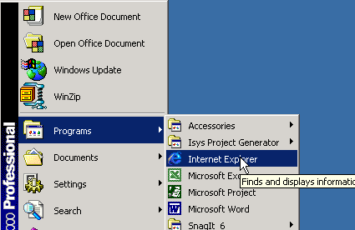

The browser window will open to the Denver Public Schools web site (or any web page that you have set up as a home page).
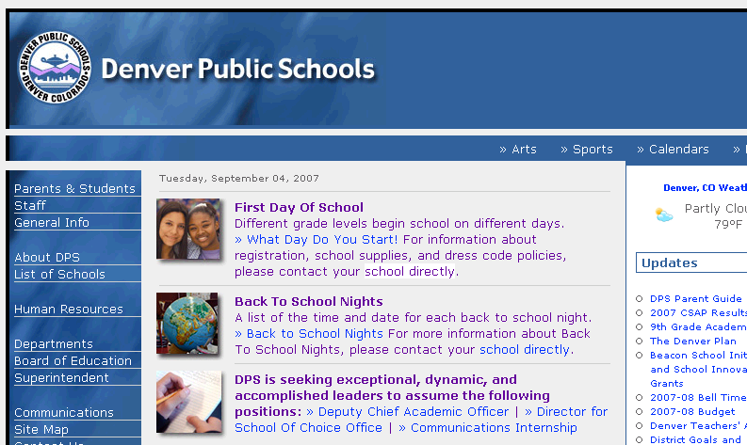

Type the following path in the address field. https://employeeinfo.dpsk12.org
The following login screen will be displayed. Please enter your SEA Time and Attendance or Manager Self-Service User Name and Password in lower-cased letters, then click on the OK button.
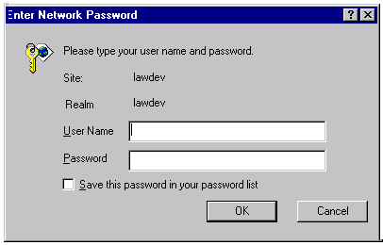

Time and Attendance Role

The screen shown on the following page is an example of the Lawson SEA screen that you will see when logged in.

You will now be at the main Time and Attendance screen.
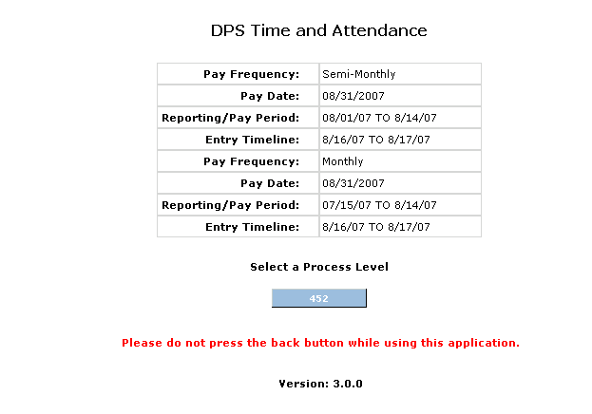
Note: If you encounter the following message after entering your User Name and Password, refer to Important Dates, Time & Attendance Payroll Schedule @ http://payroll.dpsk12.org. Time & Attendance is only available for entry during time periods listed on schedule.

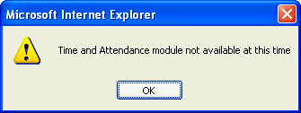

Note the Pay date for which you will be reporting time, the Reporting/pay period for which you will be reporting hours for hourly employees and/or absences and exceptions for all employees, and the Entry Timeline you must begin, complete, and submit your payroll.

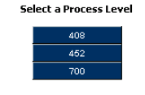
Click once on the Process Level you will be reporting payroll time for.
Click once on the Batch Number you will be reporting payroll records for.


Click once on the department or type of pay you want to enter time records for.
Note: LTS = Long Term Subs. If you have a Long Term Sub Teacher assigned to your school, hours will be submitted within the LTS Department

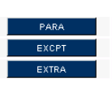

- Departments (or groups of employees) are listed separately.
ie. Paras
- The Exceptions (EXCPT) button is to enter new/ rehired employees or job changes that are not yet in they HR/Payroll system. Also use the Exception screen to enter your sub clerical.
- Extra Pay will be submitted under the “EXTRA” button

The program lists all departments at your location. A list of employees assigned to the department will appear. The Time Entry person will enter time records using the screen below. Following payroll transmittal procedures, time will be reported with accordance of payroll policy.

Time Entry

Although payroll procedures remain the same, the school/department payroll secretary will record time records for each employee at their location via a web screen instead of a paper transmittal. Each employee at your location will be grouped alphabetically, by job code, within each department at your location.

By clicking on the “Time Entry Menu” button, the system will take you to the screen below.

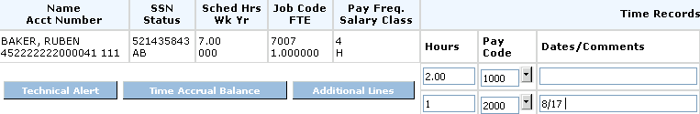

The down arrow symbol represents further help for the user. By clicking on the down arrow diamond, the user will be able to view a list of choices for the associated field.

For example, by clicking on the next to the pay code field, the following table is displayed.

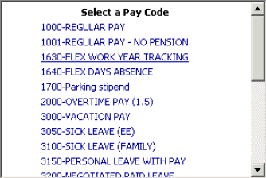

Time Accrual Balances
To view the employee’s time accrual balances (vacation, sick, flex, and personal), click once on the “Time Accrual Balances” box.

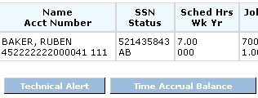

Balances will be displayed as shown below:
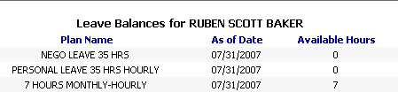

Technician Alert

To alert your payroll technician to specific comments for one of your employees, click on “Technician Alert”

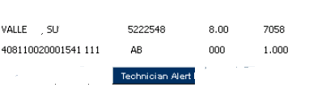
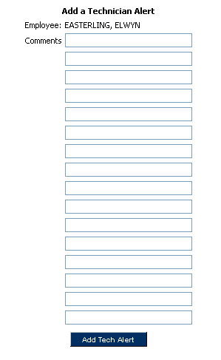
This box allows for “free form” entry and will
be forwarded to your payroll technician in the
email notification once your payroll has been
approved. The email will display your specific
comments but also the job code attached to
the time record.

Additional Entry Lines

If more than two entries are needed for one employee, click on “Additional Lines”.

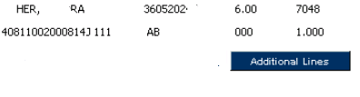

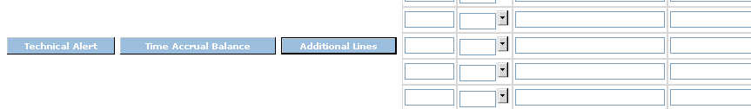

With each “click” on “Additional Lines” button, an additional line will be added to your screen. Unlimited lines are available.

Upon completion of each department, click on “Save Changes” in
the bottom right hand corner of your screen.

To delete data you have entered on an additional line, click on the delete box to the right of your entry line.
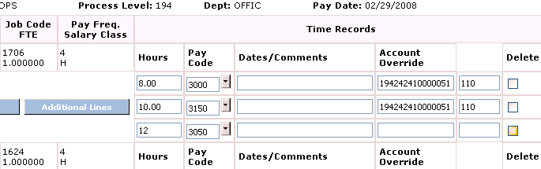
This will delete your data; however, your additional line will remain.

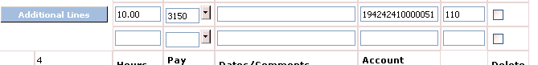

Control Hours

Control Hours: Total of all hours entered
Control Amount: Total of all hourly rates
(Hint: Use control hours to balance your payrolls and assure accuracy)
Continue with all departments, exceptions, and extra pay until your payrolls are complete. Check “Time Complete” boxes.
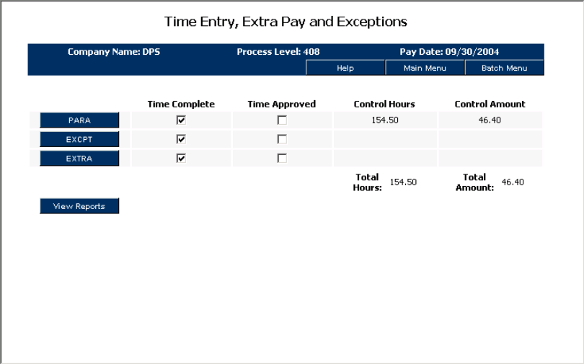

Exception Entry

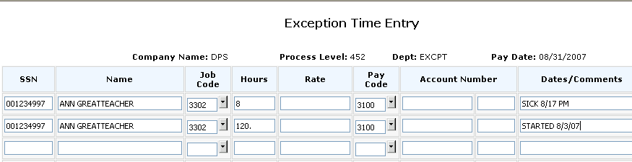
This screen is to report time worked for those employees that are not listed at your location.
- All employees must have completed fields for social security number, name, job code, and comments
- Hourly employees must have pay codes and hours submitted
If you have submitted a pace form to Human Resources, these employees will be paid on the next available payroll special once employee information has been entered into Lawson. Your Payroll Technician will contact the employee once a pay date as been confirmed.

Extra Pay Entry
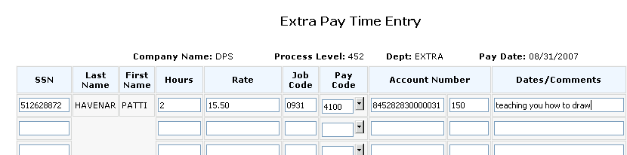
555121234 Exception Pay

555121234 Exception Pay

221134

This screen is exclusive for submitting extra pay. All fields must be populated.
- Enter the total number of extra pay hours in the column labeled “hours’
- Enter the hourly pay rate in the “rate” column. If extra pay reported is for a non-exempt employee and is for hours worked over 40 in one work week, the hourly rate must be at least 1.5 times the employee’s hourly rate.
- Exempt employees can be paid a flat dollar amount. However, use the number “1” in the “hours” field as all fields must be populated
- Enter the extra pay account number in the “account number” field.
- Provide a description and date for the extra pay being submitted
- For class coverage extra pay, list the surname of the absent teacher as well as the dates worked in the comment field

DPS Time and Attendance Reports

The reports menu is your tool for assuring the accuracy of your payrolls.

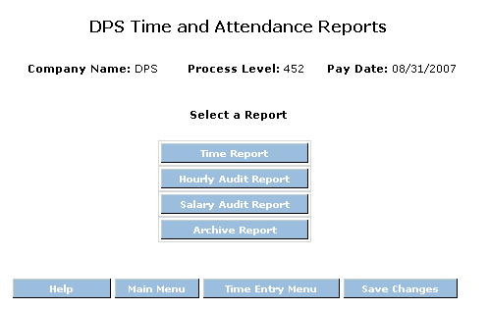

Time Report is an edit report of all time records keyed from all screens.

Hourly Audit Report is a report listing hourly employees without regular hours being submitted.

Salary Audit Report lists salaried employees who have regular hours being submitted in error.

Review previous pay period Time Reports

- Choose your report by clicking once on the box of your choice
- Click Once on Run Report
- Click once on the message “Click here to view this report”

Printing a Time & Attendance Screen

Any screen display in Payroll T & A can be printed. In order to do this, right click on the desired screen and you should see a selection of options. Click on the Print option.

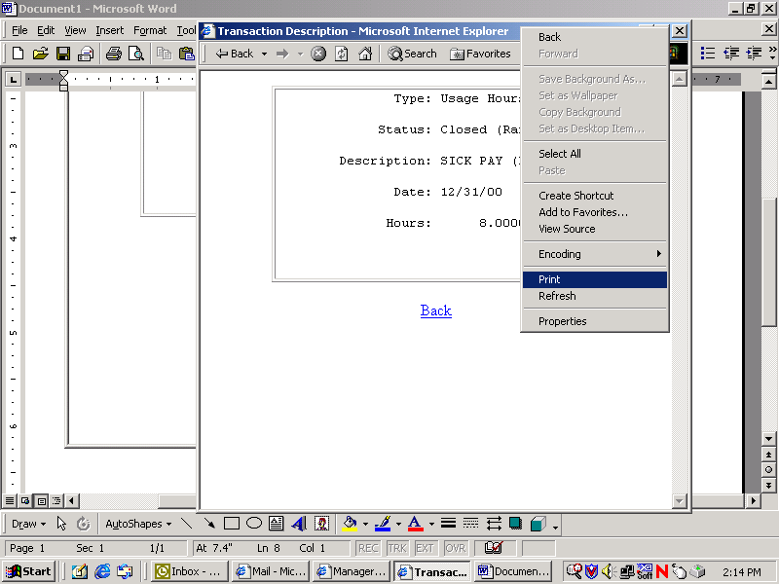

You will see a list of available printers for your workstation.

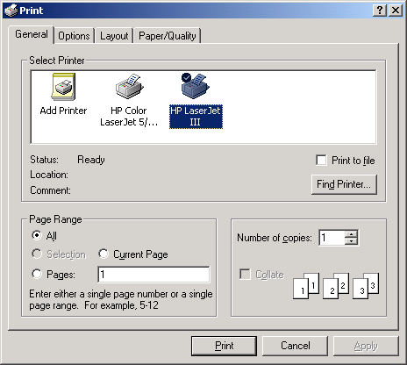

Click on the desired printer and then click on the Print button. The print dialog box will disappear when printing has completed. You will be returned to the screen display that was printed.

Time Entry Person Submitting Records for Approval

Once the Time Entry Person has completely entered her payroll and is confident of the accuracy, she will click on all boxes in the Time Complete Column.
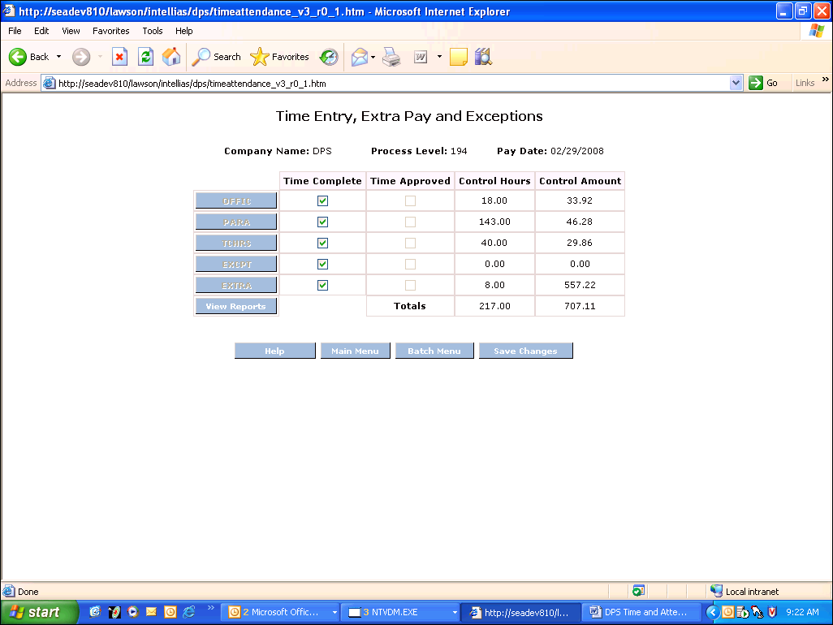
After checking boxes, click on “Save Changes”

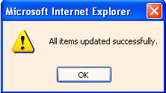 Wait for this message to appear, than Click on “OK”
A new button will appear “Submit for Approval”. 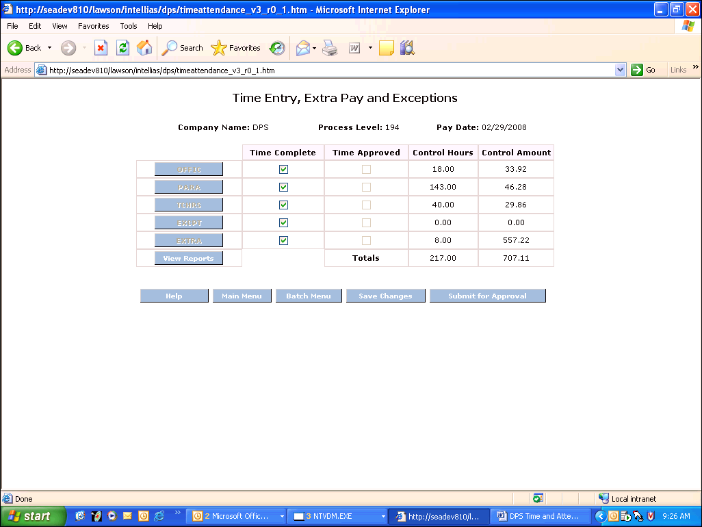

Click on “Submit for Approval” so your assigned approver can review and submit finalized payroll to the Payroll Department.
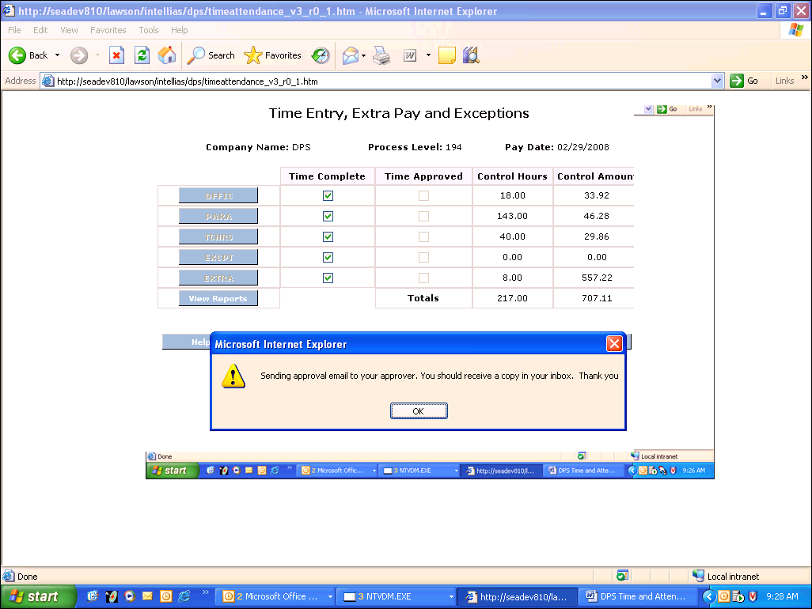
It is important to click on “OK” to assure your payroll goes to next process for approval.
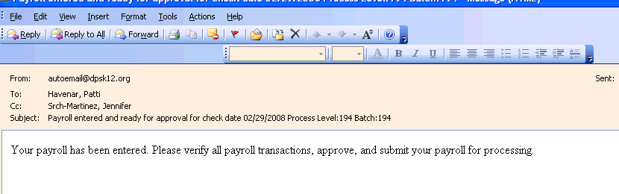
An email notification will automatically be sent to the principal/department head informing them payroll has been entered and ready for approval.

After submitting for approval, you will no longer have access to change data and your screen will be “grayed out”. In order to make any further changes to your payroll, either the approver must make the changes herself or “uncheck” the time entry box which will allow the entry person to change/add data.

Approving and Submitting to Payroll Department

Once the principal or department head has reviewed time records, she checks off each “Time Approved” box.

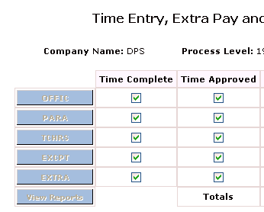
Then click on “Save Changes”


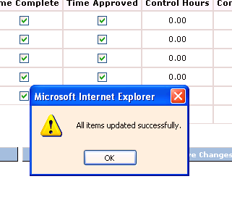
Click on “OK”
“Submit Payroll” button appears in the bottom right hand corner of the screen.
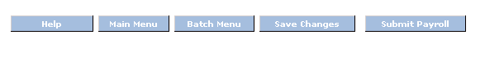
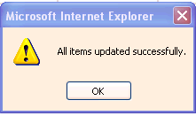
Click on “OK”

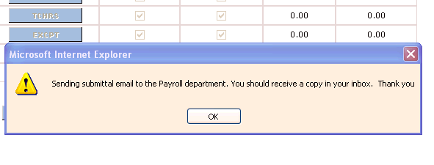
Once you see the above message box, you know that your payroll records have been interfaced for payroll processing. Unless ALL of the above steps are completed, the Payroll Department will not have your approval for paying employees at your location.

Logout

Click on the Logout button

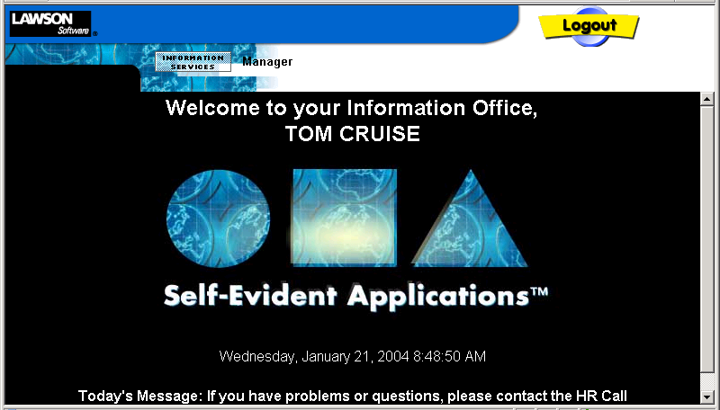

You will receive a message box as follows. You must select YES.

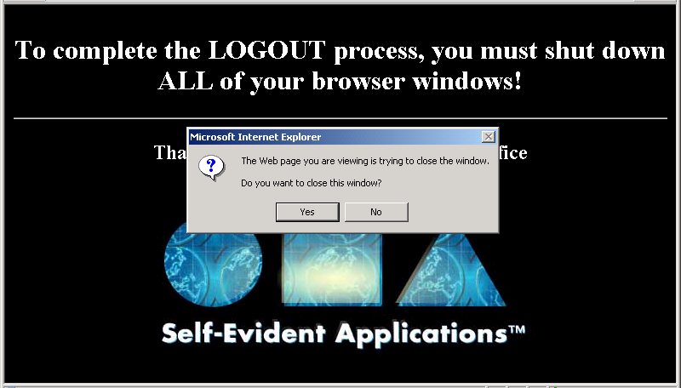
IMPORTANT: Your Internet Explorer window should automatically close. If it does not, click on X in upper right hand corner to close the browser. You must close your browser to end your session.

You will return to the original desktop.

Glossary

Batch Number: Pre-assigned # that will be used each time you enter a specific group of employees into Payroll Time & Attendance.

Control Amount: Total of rates entered.

Control Hours: Total of hours keyed in one batch. Tool to use for balancing your time records entered.

Entry Timeline: Time & Attendance is open for time entry. Secretaries should be entering time records beginning on the first day of stated timeline. Payrolls must be entered, approved, and submitted by last day stated.

Exceptions: Employees not listed at your process level. Either the name is not listed or the correct job code is not listed. This would be for new hires, re-hires, or job changes
not yet entered into Lawson HR/Payroll system.

Extra Pay: Extra hours worked outside of an employee’s normal work week and duties. This is not to include normal job duties that extend beyond the 40 hour workweek.

Overtime: Actual hours worked over 40 hours in one workweek, Monday-Sunday for non-exempt employees.

Pay Code: Identifies the type of pay to be submitted and paid.

Pay Frequency: The number of scheduled pay dates an employee has. DPS has two pay frequencies, semi-monthly and monthly.

Process Level: Your location number. Schools process level = school number.

Reporting Period/Pay Period: Semi-monthly hourly employees (work year = 000) are paid from the 1st through the 14th paid on the last working day of the month and the 15th through the end of the month paid on the 15th of the following month.

Time Accrual: Paid time off for sick, personal, and/or vacation.

